**Open Weather Map API**

Latitude Correlation: Weather Data Analysis

J. Curtis

Nov 3, 2018

This report analyzes weather data for more than 500 random cities to help answer the question of how weather changes as you approach the equator. This is primarily an analysis of the relation of latitude to four different weather parameters, namely temperature, humidity, cloudiness, and wind speed. The data gathered for this analysis is from November 3, 2018, using the free version of the Open Weather Map API for [current weather data](https://openweathermap.org/current).

One visible trend is the relationship between city latitude and max temperature (considered for Nov. 3). There is a parabolic curve visible reflecting a negative correlation between smaller latitude values, by absolute value, and the maximum temperature recorded (see fig. 1). This means that as latitude decreases when considered by abs. value, temperature increases generally. In our particular dataset, you can see the relatively smaller number of cities in the global south, although cities are represented down to approx. -58 degrees (or 58 degrees South). There are a few outliers represented around -20 to -30 degrees, which include cities around the tropic of Capricorn, including some areas near desert and arid areas in Australia and South America, but also areas with considerable rainfall during the wet season.

Figure 1

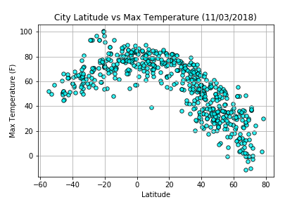

When observing the scatterplot of city latitude vs humidity, there seems to be a cluster of cities at humidity levels above 60% on this day, but a weak relationship with latitude except for a small chart area around the equator with no cities represented until you rise to around 50% humidity and above (noted in green on figure 2). This could mean that areas around the equator inside of the -10 to 10 degrees latitude bounds are generally drier. Again, on this chart the cities are skewed towards the global north.

Figure 2

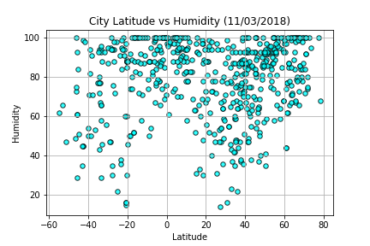

Area without cities near the equator, in the random dataset

When observing the scatterplot for city latitude vs. cloudiness, there appears to be a relatively strong relationship on this day between “bands” of current cloudiness across latitudes, and linear clusters of cities within those bands, but not a discernable relationship between latitude and cloudiness in general, including as you approach the equator (see fig. 3). The observation of “bands” of cloudiness may be a data collection artifact, or may represent the general direction of cloud bands stretching across latitudes as opposed to longitudes due to prevailing air currents. We may need more data to properly discern Hadley cells around the equator, and two strips of clouds in the mid-latitudes, which do not seem to be clearly presented here (see <https://earthobservatory.nasa.gov/images/85843/cloudy-earth>)

Figure 3

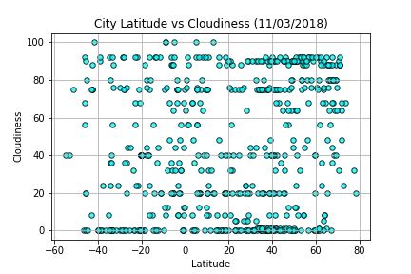

When comparing city latitude to wind speed, a weaker parabola appears, skewed as normal towards the northern latitudes. Wind appears to become weaker around the equator, increasing in strength as you cross the tropics, and continuing to increase until hitting around 27mph, barring a few outliers in higher latitudes. It is also notable that most cities from the random sample were below 15mph on this day.

Figure 4

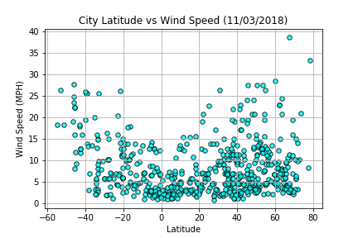

Caveats to this analysis include the need for future analysis comparing information for years at a time, as opposed to a single day, which does not normalize for which seasons each city is currently in, or where a city’s results rank in relation to normal climatic conditions in the area. Generally, land areas are less cloudy than ocean areas, and as all cities are currently land-based, the results for a city dataset are skewed towards fewer clouds more so than comparing to the entire earth’s surface. The question of the relationship of latitude to weather parameters also could benefit from more rigorous statistical analysis outside the scope of this paper.

In summary, **for this dataset of 500+ randomly-distributed cities on Nov. 3, 2018**:

1. There is a strong negative correlation between the absolute value of city latitude and maximum temperature; the hottest temperatures are generally near the equator.
2. There is a weak correlation between the absolute value of city latitude and humidity, represented mostly clearly within |10| degrees of the equator; there are few cities near the equator with less than 50% humidity.
3. There is no visually discernable relationship between city latitude and cloudiness for this dataset; areas near the equator are equally distributed amongst the range of cloudiness
4. There is a weak positive correlation between the absolute value of city latitude and wind speed; areas near the equator have low wind speed compared to other cities